Basic Authentication:

URL : <https://postman-echo.com/basic-auth>

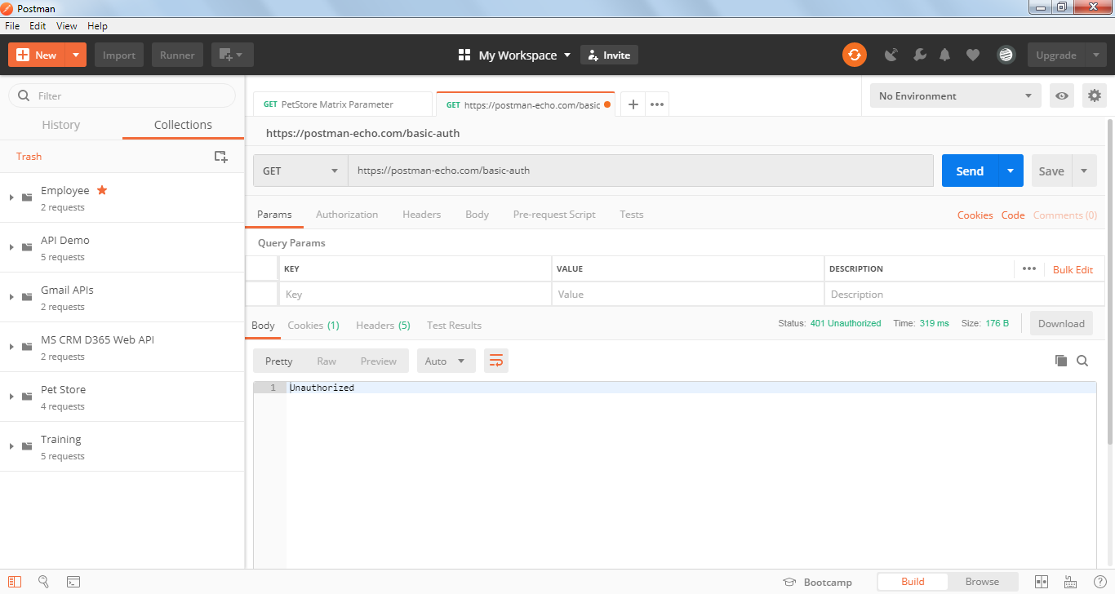

When running the request without username and password getting 401 as the API accepts basic authentication

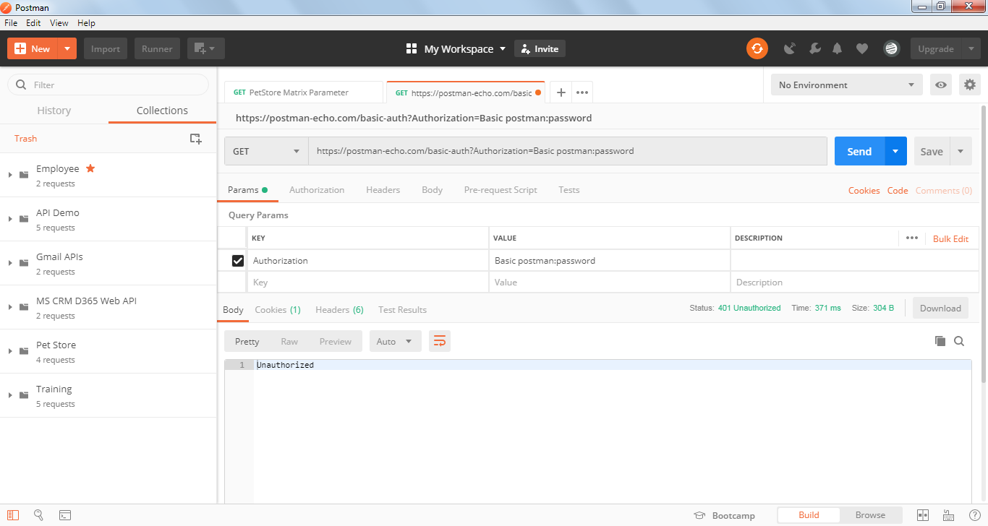

Now running with Basic authentication

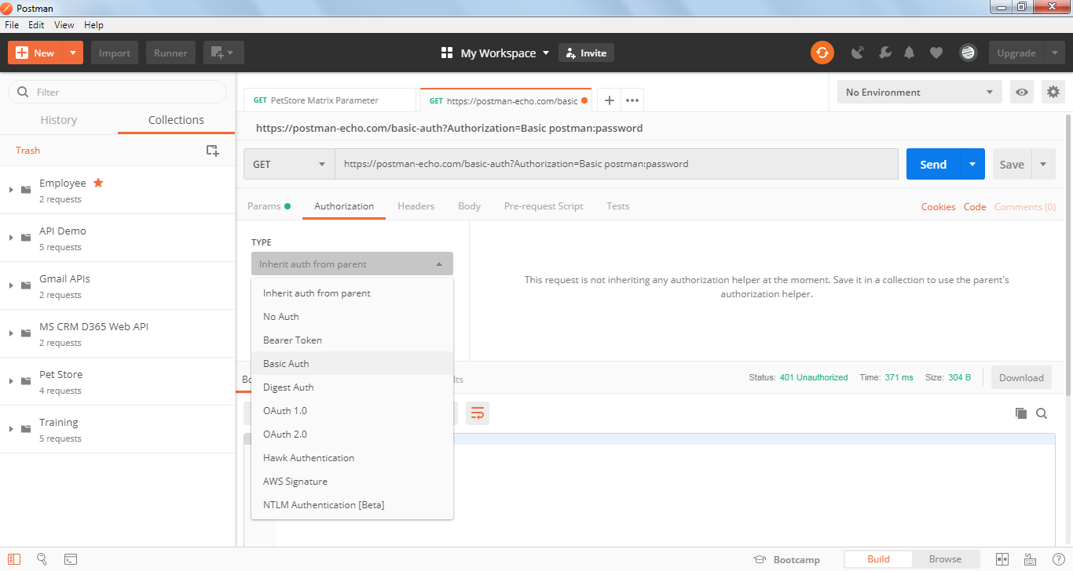

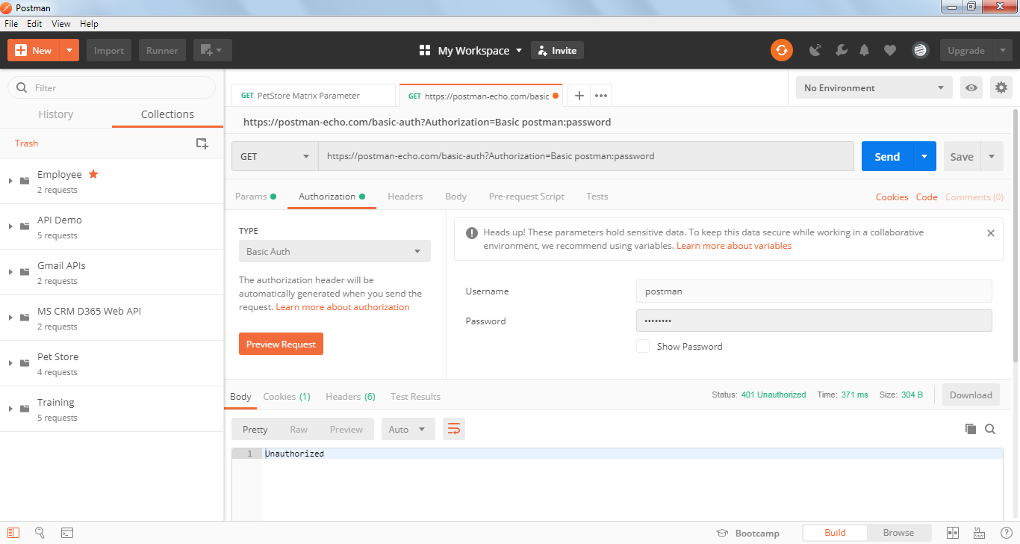

Click on Preview Request and then go to Headers

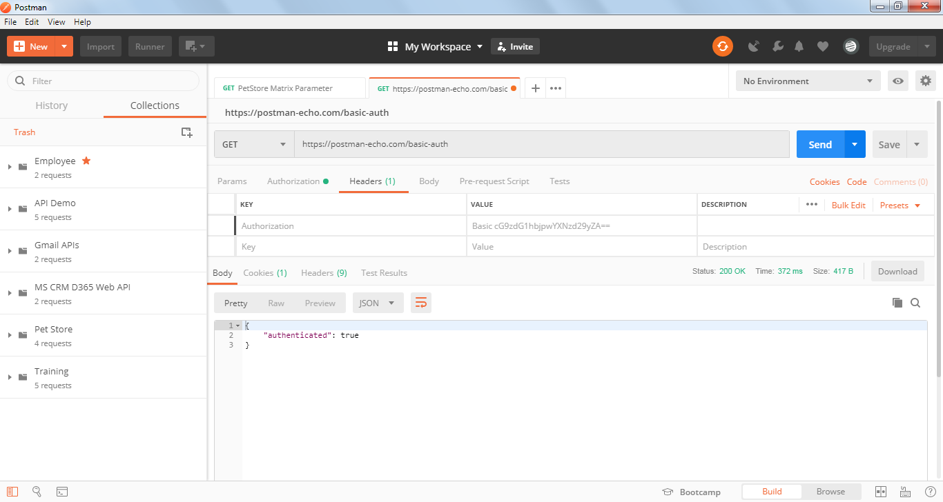

Basic Authentication requires a Header with name ‘Authorization’ with base64 encoding of application ‘username:password’ prefixed by Basic keyword separated by a space.

Steps to generate base64 encoding outside postman:

<https://www.base64encode.org/>

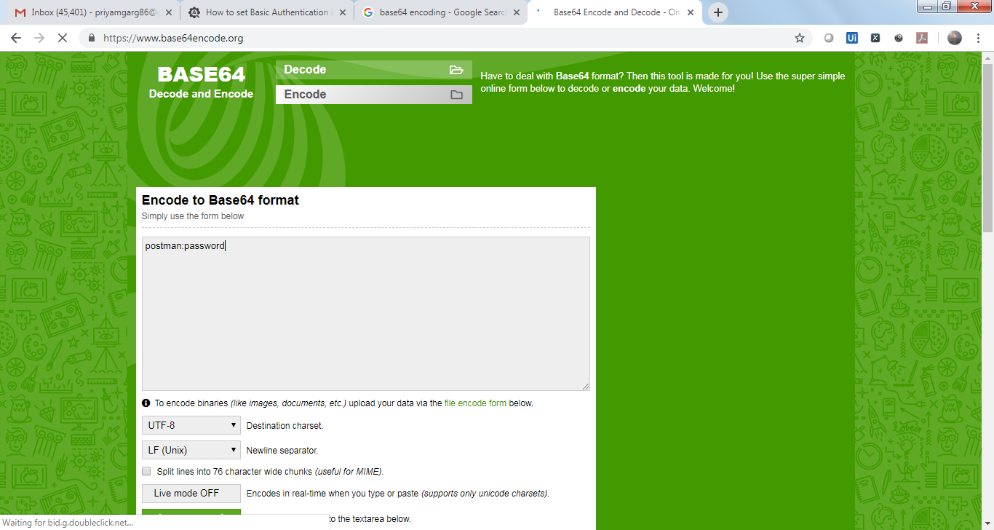

Click on encode:

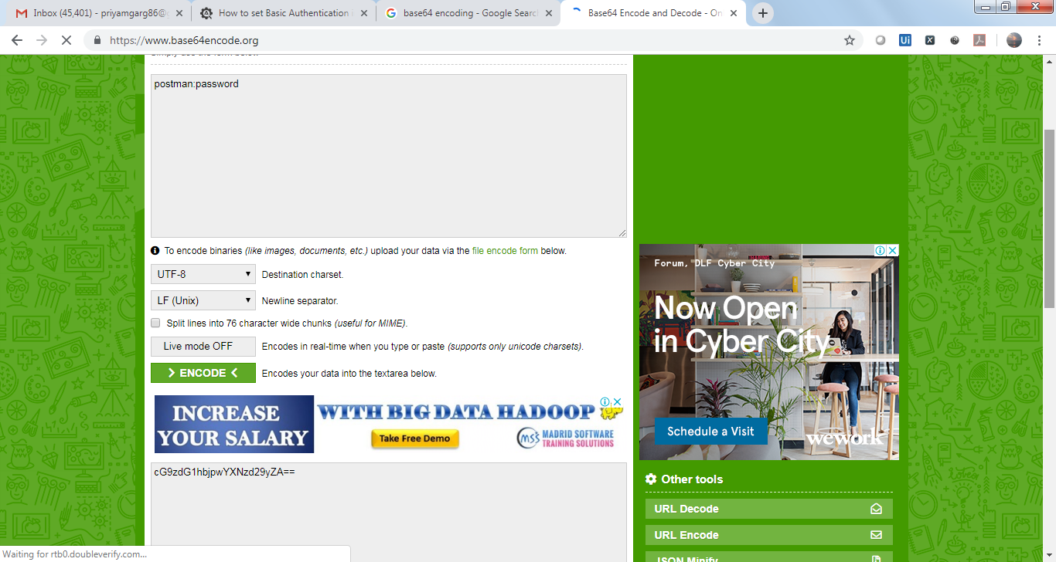

So header ‘Authorization’ used should be

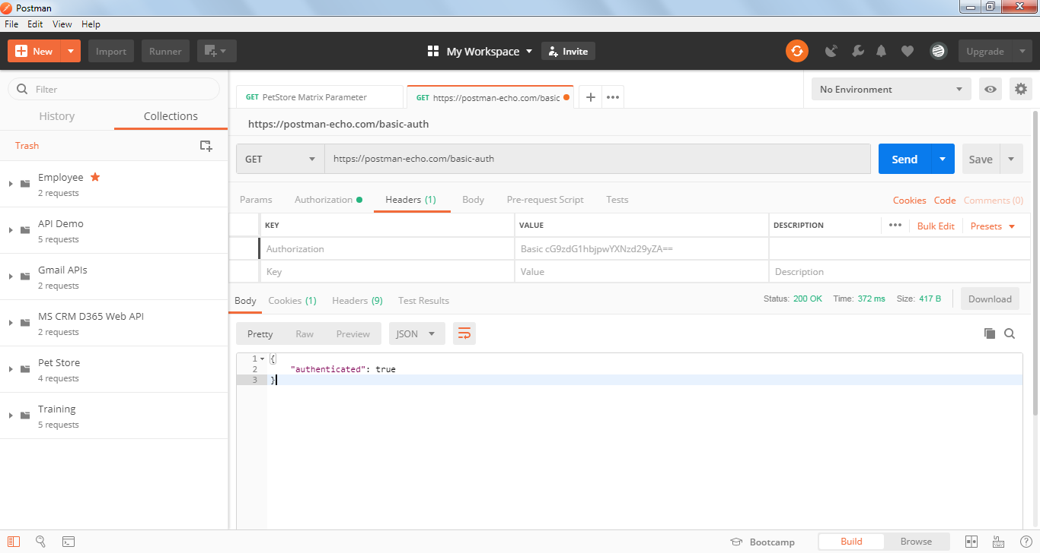

Oauth 2.0 Authentication

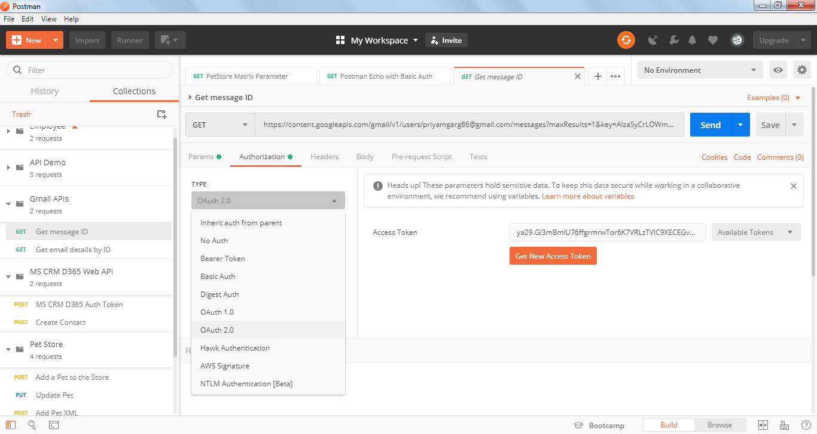

Click on Get New Access Token

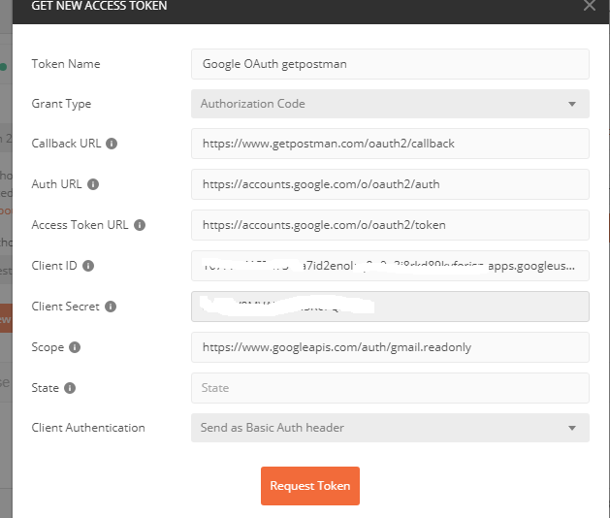

Click on Request Token

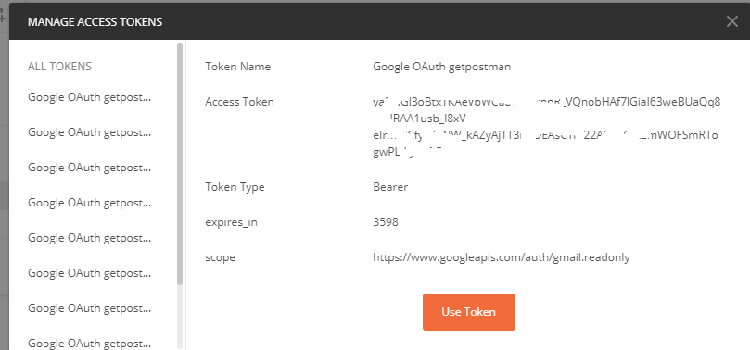

Use Token

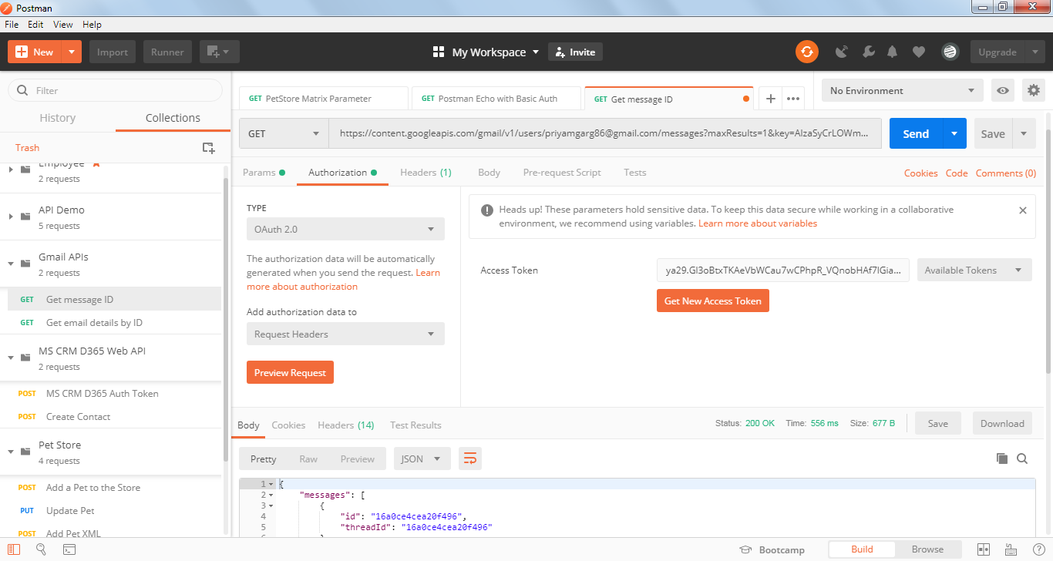

API ran successfully displaying the message id.

The Access Token is sent in ‘Authorization header’ with ‘Bearer’ as prefix separated by a space as shown below:

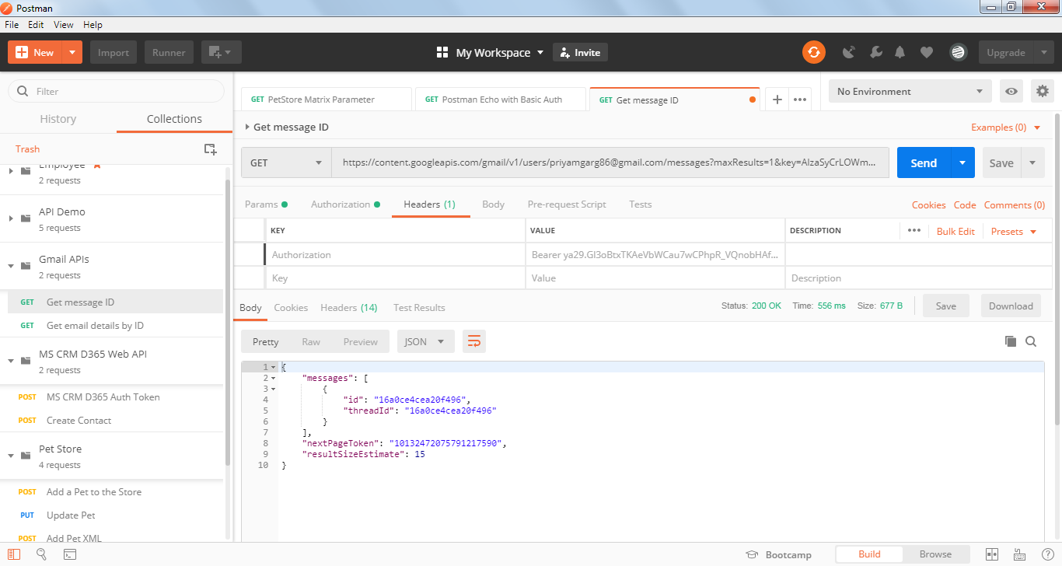

In this example i have used Gmail APIs as an example for Oauth2.0 authentication

For using Gmail APIs you need to register your machine and account with Gmail to get a ‘key’ and ‘client secret’ along with the permission to use APIs for your account.



With key and client secret an Access Token can be generated using above method in Postman